Dear Colleagues,

Please find attached the placement offer form of a Greek NGO named "Archipelagos"
concerning various fields:

1.Marine Research & Conservation

2. Fisheries Research & Management

3. Forest & Freshwater Ecosystem Management

4. Research & Conservation of Island Flora & Fauna

5. Agronomic Research & Seed Bank Projects

6. Laboratory Assessment of Environmental Impacts

7. GIS Mapping of Marine & Terrestrial Habitats & Biodiversity

8. Applications of Renewable Energy Sources

9. Illustration of Flora & Fauna of the Aegean Sea

10. Graphic Design for Environmental Awareness Material

11. Animation

12. Environmental Photography in the Region of the Aegean Sea

13. Documentary Film Production

14. Environmental Education

15. Information Technology

16. Legal Work

17. Public Relations

18. Administrative Work

For further details, please also see the following forwarded message.

We would like to remind you that all GR ERASMUS placements offers are also published
in our website :
http://www.iky.gr/IKY/portal/en/default/CMSENWindow?action=2&uri=/en/socrates/erasmus/workplace.html

Kind Regards,
Margarita Stoeva
Expert, Erasmus
"Selection, contracting and analysis"
Human Resource Development Centre
Bulgaria

"Dear all,

I am writing to you on behalf of Archipelagos, Institute of Marine Conservation
(www.archipelago.gr), a Greek non-profit, non-governmental organization, committed
since 1998 to the research and conservation of the marine and terrestrial
environments of the Greek seas and islands.

For over a decade, Archipelagos has also been providing opportunities for students
and recent graduates from EU, USA and other foreign country universities, to
acquire multidisciplinary, practical work experience in the institute's research
bases and stations located on five islands and islets in the eastern Aegean Sea as
well as two research sailing boats. Since 2001, we have hosted educational
activities, with over 1000 participants from all over the world.

Archipelagos is currently seeking to establish new collaborations with
universities in the xxx, with the aim to promote and expand the educational
activities that we offer. Both the placements and field courses that we organize
give students and young graduates opportunities to gain hands-on experience in
applied environmental conservation work. Our activities also are suitable for
academic staff and university researchers.

1. Archipelagos' Placements generally have a duration of between 3 and 12 months,
however placements for groups and students collecting dissertation data can be
more flexible.

The placements for 2012 cover the following fields:

1. Marine Research & Conservation

2. Fisheries Research & Management

3. Forest & Freshwater Ecosystem Management

4. Research & Conservation of Island Flora & Fauna

5. Agronomic Research & Seed Bank Projects

6. Laboratory Assessment of Environmental Impacts

7. GIS Mapping of Marine & Terrestrial Habitats & Biodiversity

8. Applications of Renewable Energy Sources

9. Illustration of Flora & Fauna of the Aegean Sea

10. Graphic Design for Environmental Awareness Material

11. Animation

12. Environmental Photography in the Region of the Aegean Sea

13. Documentary Film Production

14. Environmental Education

15. Information Technology

16. Legal Work

17. Public Relations

18. Administrative Work

More information on the placements can be found in www.archipelago.gr

2. Archipelagos' Field Courses combine teaching sessions by experts, with applied
field work that is part of on-going priority conservation projects.

Field courses can also be tailored to meet the needs and interests of the
participating university and students. More information on the field courses can
be found in the 'Field course Leaflet'. Click 'here' to watch a video of the
annual Marine Conservation field course conducted by final year Marine Geography
students from Cardiff University.

Field courses for 2012 are:

1. Applied Marine Reseach & Conservation: Marine Mammals, Fisheries & Littoral
Ecosystems

2. Underwater Photography & Scientific Illustration

3. Forest Management & Conservation

4. Wildlife Filmaking

5. Law & Policy for Environmental Conservation

6. Applied Marine Research & Conservation - An interdisciplinary approach of
scientific research and Law & Policy

3. Postgraduate research opportunities are also offered at Archipelagos in a
variety of fields, in collaboration with various E.U. and U.S. universities. For
more detailed information please email a.miliou@archipelago.gr

If you are interested to discuss further such a collaboration, please contact me.

Anastasia Miliou"

________________________________________
Yannis Koutelidas
Communications Coordinator
Archipelagos, Institute of Marine Conservation
M. Voda 89, 10440, Athens, Greece
tel. +30 2108253024
yannis@archipelago.gr
www.archipelago.gr

Marine Research Base
P.O. Box 152, Ormos, Marathokampos 83102, Samos, Greece
tel +30 22730 37533

Terrestrial Research Base
P.O. Box 1, Rahes 83301, Ikaria, Greece
tel +30 22750 41070

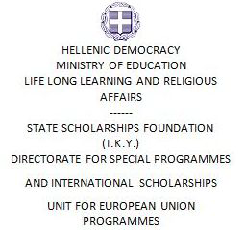

Placement Offer Form
1, Makri & Dionysiou Aeropagitou Str., 117 42 Athens
e-mail: erasmus@iky.gr
Ph.: +30 210 3726351/ Fax: +30 210 3221863

EMPLOYER INFORMATION
Name of Organization

Address

Postal Code
City

Country

Telephone

Fax

e-mail

Website

Number of Employees

Year of Foundation

Contact Person

Department/Function

Direct Telephone Number

Direct Mobile

Direct e-mail address

Short Description of the Company
(Please attach profile of your company, max 1 page)
Other

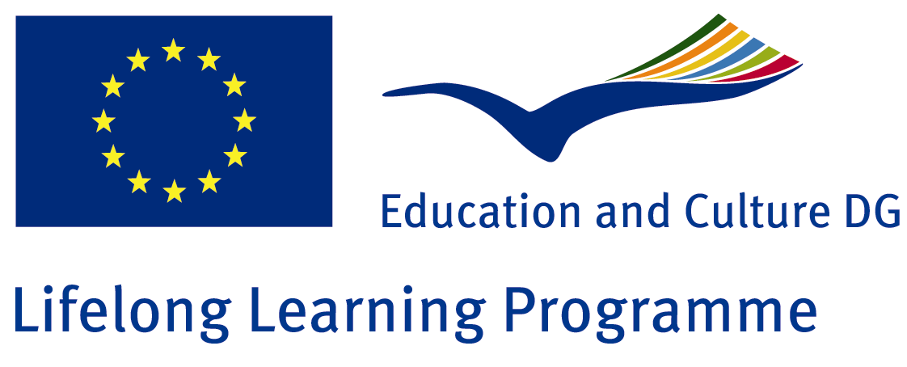

PLACEMENT INFORMATION
Number of positions offered for student placement
In the Department/Function (where the position is offered)
Description of activities the student will be involved in
Duration | months
Working Hours/Weekly Hours | /
City
Help with finding  Accommodation | □ Yes  □ No
Financial Contribution | □ Yes €  □ No
Other
REQUIREMENTS
Study Field | (Please choose a field/s from Table A: pages 3, 4, 5 & 6 of this form)
Oral and Written Language Skills | □ Greek (level: )  □ English (level: )  □ French (level: )  □ German (level: )  □ Other (level: )
Computer Skills
Drivers license | □ Yes □ No
Other

Should you have any questions, please do not hesitate to contact us.

Place______________________________________Date_______________________

Signature_______________________________________

P.S. The more information you are able to give us on this form, the better we are able to match your offer to a student!
Please return this form by e-mail erasmus@iky.gr

Table A - Fields of Education & Training

X | Description
 | General Programmes
 | Basic/broad, general programmes
 | Basic/broad, general programmes
 | Literacy and numeracy
 | Literacy and numeracy
 | Personal skills
 | Personal skills
 | Education
 | Teacher training and education science
 | Teacher training and education science (broad programmes)
 | Teaching and training
 | Education science
 | Training for pre-school teachers
 | Training for teachers at basic levels
 | Training for teachers with subject specialisation
 | Training for teachers of vocational subjects
 | Teacher training and education science (others)
 | Humanities and Arts
 | Arts
 | Arts (broad programmes)
 | Fine arts
 | Music and performing arts
 | Audio-visual techniques and media production
 | Design
 | Craft skills
 | Arts (others)
 | Humanities
 | Humanities (broad programmes)
 | Religion
 | Foreign languages
 | Mother tongue
 | History and archaeology
 | Philosophy and ethics
 | Humanities (others)
 | Social sciences, Business and Law
 | Social and behavioural science
 | Social and behavioural science (broad programmes)
 | Psychology
 | Sociology and cultural studies
 | Political science and civics
 | Economics
 | Social and behavioural science (others)
 | Journalism and information
 | Journalism and reporting
 | Library, information, archive
 | Journalism and information (others)
 | Business and administration
 | Business and administration (broad programmes)
 | Wholesale and retail sales
 | Marketing and advertising
 | Finance, banking, insurance
 | Accounting and taxation
 | Management and administration
 | Secretarial and office work
 | Working life
 | Business and administration (others)
 | Law
 | Law
 | Science, Mathematics and Computing
 | Life science
 | Biology and biochemistry
 | Environmental science
 | Life science (others)
 | Physical science
 | Physical science (broad programmes)
 | Physics
 | Chemistry
 | Earth science
 | Physical science (others)
 | Mathematics and statistics
 | Mathematics
 | Statistics
 | Mathematics (others)
 | Computing
 | Computer science
 | Computer use
 | Computing (others)
 | Engineering, Manufacturing and Construction
 | Engineering and engineering trades
 | Engineering and engineering trades (broad programmes)
 | Mechanics and metal work
 | Electricity and energy
 | Electronics and automation
 | Chemical and process
 | Motor vehicles, ships and aircraft
 | Engineering and engineering trades (others)
 | Manufacturing and processing
 | Manufacturing and processing (broad programmes)
 | Food processing
 | Textiles, clothes, footwear, leather
 | Materials (wood, paper, plastic, glass)
 | Mining and extraction
 | Manufacturing and processing (other)
 | Architecture and building
 | Architecture and town planning
 | Building and civil engineering
 | Architecture and building (others)
 | Agriculture and Veterinary
 | Agriculture, forestry and fishery
 | Agriculture, forestry and fishery (broad programmes)
 | Crop and livestock production
 | Horticulture
 | Forestry
 | Fisheries
 | Agriculture, forestry and fishery (others)
 | Veterinary
 | Veterinary
 | Health and Welfare
 | Health
 | Health (broad programmes)
 | Medicine
 | Nursing and caring
 | Dental studies
 | Medical diagnostic and treatment technology
 | Therapy and rehabilitation
 | Pharmacy
 | Health (others)
 | Social services
 | Child care and youth services
 | Social work and counselling
 | Social services (others)
 | Services
 | Personal services
 | Personal services (broad programmes)
 | Hotel, restaurant and catering
 | Travel, tourism and leisure
 | Sports
 | Domestic services
 | Hair and beauty services
 | Personal services (others)
 | Transport services
 | Transport services
 | Environmental protection
 | Environmental protection (broad programmes)
 | Environmental protection technology
 | Natural environments and wildlife
 | Community sanitation services
 | Environmental protection (others)
 | Security services
 | Security services (broad programmes)
 | Protection of persons and property
 | Occupational health and safety
 | Military and defence
 | Security services (others)
 | Other (please list)

