Solar PV systems for the needs of agriculture

Dependence on sunshine is one of the factors that link the operation of solar PV systems with the processes that take place in agriculture. This is one of the reasons why photovoltaic systems are such a suitable addition to agricultural production at any scale.

Agrivoltaics at a global scale

Agriculture is one of the economic sectors most affected by climate change. At the same time, it is one of the main culprits: intensive crops produce 12% of global greenhouse gas emissions. Renewable energy is an inexhaustible resource, unlike coal and petrol. Globally, the combination of agricultural production and the production of energy from sunlight within the same agricultural area is known as “agrivoltaics”. Growing crops under and around solar PV panels creates a favorable climate and good growing conditions. Often these are high-power photovoltaic power plants (FPPs) that are built on areas planted with crops or that are used as pastures for livestock farms.

Figure 1. Agrivoltaics on vineyards (Source: PV Magazine)

Theory and practice show that there is a lot of potential for synergy between the two types of production. This is especially true when growing crops or animals that require wind protection or shade. The combined application can increase the efficiency and productivity of both HPPs and agriculture by reducing water evaporation. In this way the yields from agricultural production increase. The construction of solar PV power plants in agriculture further contributes to reducing the cost of electricity in processing plants and enterprises to farms and increases their competitiveness.

Solar PV for Bulgarian agriculture

In Bulgaria, however, the application of off-grid solar PV systems to supply part of the energy needs of agriculture is more popular. It is often the case that suitable places for agricultural development are located in hard-to-reach areas, far from the distribution network. This makes off-grid solar PV systems a far more sensible and efficient option for agriculture.

In addition, farmers have access to financing for the installation of solar PV systems under Measure 4.1 “Investments in agricultural holdings” and Measure 4.2 “Investments in processing and marketing of agricultural products” of the Rural Development Program (RDP) 2014-2020. Renewable energy sources are a priority in the RDP and can bring many benefits.

Systems for basic energy needs

Most often in our practice we have installed off-grid power supply systems for the basic needs of farmers. Such is, for example, the system we built for the needs of a livestock farm in the village of Dolen, Satovcha Municipality. The system is equipped with 3 monocrystalline panels with a capacity of 150W each, a hybrid inverter FSP 12V / 1000W and a Monbat Megalight 205Ah battery. It can power the farm’s needs for lighting, TV and a small refrigerator. The hybrid inverter allows the connection of a backup power source, such as a fuel generator, in case more power is needed.

Off-grid photovoltaic systems can be of any size, depending on the needs of the specific agriculture.

In the village of Novo Khodzhovo, Sandanski Municipality, for example, we installed a larger hybrid system for the needs of a cherry orchard (Figure 2). This system consists of 12 monocrystalline solar PV panels of 300W each from SunRise Energy, 8 Rolls 6V / 250Ah batteries and one inverter Voltronic 48V / 5000W with a built-in MPPT controller. The system is adapted to supply the needs of the adjacent facility, including lighting, refrigerators, cameras, computers.

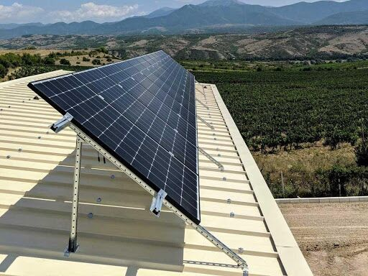

Figure 2. Hybrid system on a cherry orchard in the village of Novo Hodjovo, Sandanski Municipality

Solar PV systems for irrigation

Photovoltaic systems are a very suitable solution for powering irrigation systems. They can be implemented in two main ways. In one, an existing water pump can be converted into a solar one by means of a special inverter. In the second, a solar pump can be installed directly without the need for an inverter.

In order to be able to design the most optimal system possible for the specific needs in the first scenario, we need to know the power capacity of the pump. Usually, the panels need to have 20-30% more power than the pump, so that it can work even during temporary clouding. For example, if the pump has a power capacity of 1,200W, we recommend panels with a total capacity of at least 1,500W, and for greater security – 2,000W.

After connecting the pump to the solar PV panels and inverter, all that is needed is the sun. When there is sun, the pump runs continuously. If the power coming from the panels drops, it reduces the speed of the pump until the full power from the panels is restored. If the power decreases a lot (in the presence of a dense and large cloud), then the pump stops and waits for power to recover.

In the second option, the system works in exactly the same principle, but more technical information is needed to select the most suitable solar pump for the specific needs. This includes data on borehole drilling depth, required head and flow rate per hour.

Energy storage for agriculture

There is also an option to add a battery bank to be used in the dark parts of the day or in bad weather when the production of the solar PV panels is not sufficient. In order to offer a suitable battery pack, we must have information on how much stock the system must have, expressed in a number of operating hours of the pump.

The interesting thing about solar PV systems is that they allow another efficient way to store energy – by placing a buffer tank for water storage (Figure 3). In this way, the available energy, when the sun is shining, can be stored in the form of water reserves, which can be used at a later stage for irrigation in the cloudy or dark hours of the day.

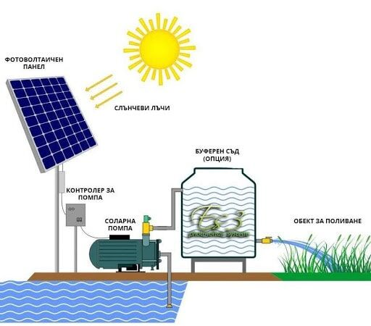

Figure 3. Scheme of operation of a solar PV irrigation system

Off-grid irrigation system in the town of Septemvri

We designed and installed a power supply system for an automated irrigation system for strawberry plantations in the town of Septemvri. The system consists of 3 Canadian Solar 265W polycrystalline panels, one FSP 24V / 3000W hybrid inverter and two Monbat Megalight 190Ah batteries.